Lab 4: CHEMICAL REACTIONS: A CYCLE OF COPPER REACTIONS

Pre-Lab Activity
In this lab activity you will carryout 5 reactions involving copper and other reactants. This series of reactions will begin with elemental copper as the initial reactant and then end with the same elemental copper as a final product. As a pre-lab activity, each of you will write out, in your lab notebook (under a Prelab heading), all 5 reactions (separately; do not just copy the scheme below) shown in the schematic below. Each reaction needs to be completed, balanced and all physical states (s, l, g, aq) noted.
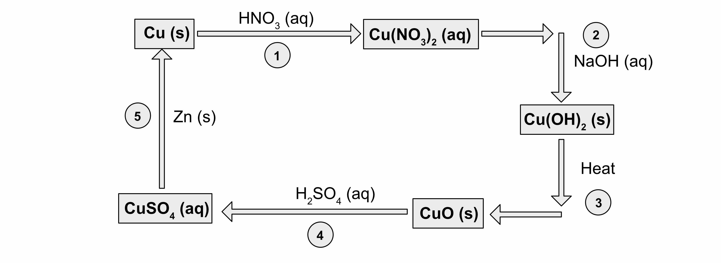

During this series of reactions you will note many color changes; you will record these observations in your lab notebook. Also, this activity will evaluate your “quantitative lab technique;” if you start with 0.50 grams of copper then you should end with ~ 0.5 g of copper. Use good lab technique when transferring materials.

(over for procedure)
PROCEDURE (work independently during entire lab period)
Note 1: this is a quantitative experiment, and the actual yield should come close to 100%.
Note 2: Record all observations before, during, and after the reactions.

RXN 1: Oxidation of Copper solid. Obtain a piece of copper wire (~0.5 g = ~10 cm) and clean it as described in the pre-lab discussion. Once clean, handle the copper only with forcepts and/or Kimwipes. Weigh the copper on the analytical balance to ±0.0001 g and record in your lab notebook.

Place the copper in a 250 mL beaker and — in the fume hood — add ~4.0 mL of concentrated (16 M) nitric acid; cover the beaker with a watch glass. Record your observations. Once the copper has completely reacted and is now in solution, recover any copper that has sprayed onto the watch glass by squirting the underside with distilled water and allowing the rinse to collect in the beaker. Rinse the sides of the beaker and then continue adding water until the beaker contains ~125 mL of solution.

RXN 2: Formation of Cupric Hydroxide. While stirring the solution, add 30 mL of 3.0 M NaOH, ~1 mL at a time using a transfer pipet.

RXN 3: Formation of Cupric Oxide. Using a hot plate, heat the solution (~155 mL total) near boiling while stirring to prevent “bumping” (“bumping” is when a solution becomes superheated and then undergoes a sudden release of a large vapor bubble, forcing liquid outside of a flask). Continue heating for 5 minutes after a noticeable transformation has occurred; this action will “coarsen” the precipitate and allow it to settle faster. Remove from heat and allow to cool. In a separate beaker (400 mL) heat 200 mL of distilled water for washing the precipitate.

As the reaction beaker cools the product (CuO) will settle to the bottom. Wait until the precipitate is about 1/4 the height of the liquid and carefully decant the supernatant (the liquid portion) into a clean beaker. Be careful to not lose any precipitate while decanting since this will effect your overall quantitative yield. If precipitate is transferred while decanting, let any precipitate settle in the second beaker, decant again, and combine with the main product. Add the hot wash water to your precipitate, let the CuO settle, and decant once more, leaving behind the CuO solid in as small amount of water as possible. Note: we could use a Buchner funnel (as in the aspirin lab) to completely separate the solid from all wash water, but we are not interested in collecting the CuO solid at this time.

RXN 4: Dissolution of Cupric Oxide. To the CuO solid in a small amount of water, add 15 mL of 6.0 M H2SO4, while stirring.

RXN 5: Reduction of Copper ions. Add ~3 g of zinc metal and cover the beaker with a watch glass to prevent acid spray; 2D swirl occasionally. The release of hydrogen gas is part of an unavoidable side reaction; please write out this side reaction in your lab notebook. When the solution has become colorless, allow the reaction to continue another 5 min.

Processing of Copper Metal.
The copper metal product must be “cleaned-up” using the following steps:

Removal of excess Zn. Excess zinc metal was added in RXN 5 and must now be removed. Zinc metal, but not copper metal will react with aqueous hydrochloric acid; add ~10 mL 6M HCl to the solution. This reaction will generate hydrogen gas; after gas evolution has slowed, heat on a hot plate until a no additional gas is evolved. Cool, decant and wash the copper metal three times with ~100 mL distilled water, taking care to rinse the walls of the beaker.

Washing copper metal with acetone. On the analytical balance, weigh a clean, dry porcelain evaporating dish; record this weight in your lab notebook. Using a glass rod, transfer the slightly wet Cu from the beaker into the dish. Rinse any remaining copper metal out of the beaker into the dish. Decant off the excess water and wash twice with acetone by adding ~10 mL of acetone, swirl, and decant.

Drying and weighing. Place the evaporating dish on a hot plate and heat for 5 minutes; this will remove (evaporate) the acetone (boiling point 56°C). After the sample looks dry and there is no residual odor of acetone, wait a few more minutes, then remove the dish from the hot plate and place it on a the cool bench; allow the dish to cool for a few minutes. Weigh the dish on the analytical balance and record this mass in your lab notebook.
Instructors Notes:
The balanced chemical equations corresponding to each step are written below.

(+1/+4/-2) (0) (+2/+4/-2) (+1/-2) (+4/-2)
(1) 4 HNO3(aq) + Cu(s) → Cu(NO3)2(aq) + 2 H2O(l) + 2 NO2(g)

Oxidation-Reduction Reaction: Nitric acid (HNO3) is not only a strong acid but a strong oxidizing agent. Cu(s) is oxidized and some of the “N” in the nitrate is reduced

(2) Cu(NO3)2(aq) + NaOH(aq) → Cu(OH)2(s) + NaNO3(aq)

Precipitation Reaction: Many heavy metals form insoluble hydroxides, which precipitated from solutions of their salts mixed with soluble hydroxides such as NaOH.

(3) Cu(OH)2(s) + heat → CuO(s) + H2O(l)

A standard “reaction”: Many transition metal hydroxides lose water on heating, changing to oxides. (Base - water = base anhydride.) For Cu, this reaction happens at an unusually low temperature, and is accompanied by a striking color change.

(4) CuO(s) + H2SO4(aq) → CuSO4(aq) + H2O(l)

pseudo Displacement reaction; Metal oxides, being base anhydrides, form salts with acids just as readily as do the bases themselves.

(5) CuSO4(aq) + Zn(s) → Cu(s) + ZnSO4(aq)

Double displacement Reaction: Active metals, such as zinc, readily displace less active metals from their salts. Stated in a slightly different way, Cu²⁺ ions are more reactive than Zn²⁺ ions, therefore Cu²⁺ will strip electrons from Zn(s).

When Zn(s) is added to the reaction mixture from reaction 4, there is excess H₂SO₄. This excess H₂SO₄ will reaction with the Zn(s) to form hydrogen gas:

Zn(s) + H₂SO₄ (aq) → ZnSO₄(aq) + H2 (g)

Cleaning up the Copper…there is excess Zn(s) mixed with the Cu(s), so one of the “cleaning” steps has the student add HCl (aq) to the Cu (s). The HCl (aq) will react with the Zn (s), but not the Cu (s).

Zn(s) + HCl₂ (aq) → ZnCl₂(aq) + H2 (g)
Additional Comments:
1) Start the Cu (s) reaction with HNO3 (aq) BEFORE the prelab…it takes ~20 mins for the metal to react (depending on the form of the copper).
2) Students always wait too long for the black CuO (s) to settle.
3) Don’t add ALL of the Zn (s) in step 5…add half, then add more if the blue color does not go away.

