Homework: Chem 312 Name ____________________________
Constant pressure work
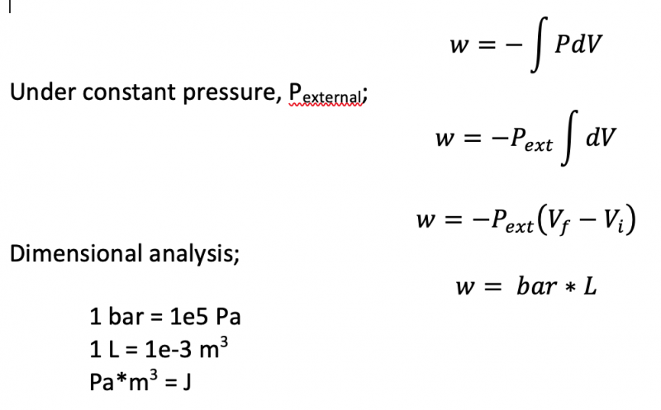
Consider the following constant pressure, isothermal compression:
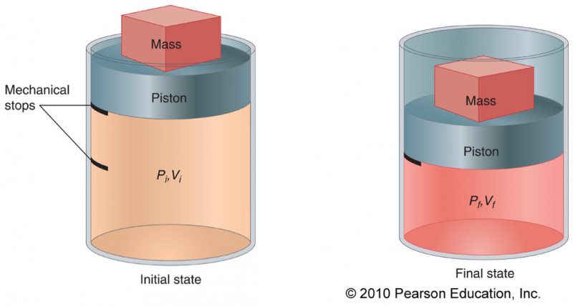
Q: If the initial volume is 2.5 L and the final volume is 2.0 L, and this work is being done under a constant external pressure of 1.01 bar, how much compression work (in J) has been done?

